How to install & configure an Veeam 9.5
1 Introduction 2
2 Prerequisites 2
3 Step-by-step plan 4

Introduction
This manual is intended as guide for configuring VEEAM 9.5

Prerequisites
- Script: ConfigureVeeam9.5
- License: veeam_backup_perpetual_560_0.lic
- ISO: VeeamBackup&Replication_9.5.0.823.Update1.ISO
- Synology cluster with SRV_BACKUP configured
- Secondary network card in backup VM with correct IP address:
  - 172.16.2.18
  - 255.255.255.128
- vCenter & ESXi’s with SRV_BACKUP configured
- SRV_BACKUP user for the domain

Step-by-step plan

- Make sure all prerequisites are met
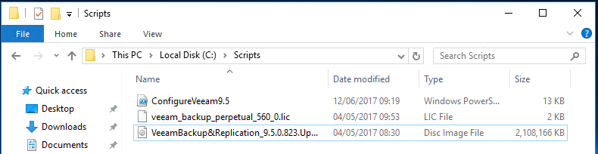
- Mount the Veeam ISO and start the installer.
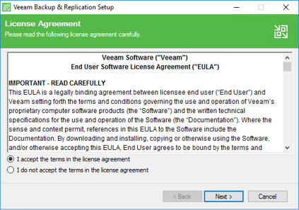
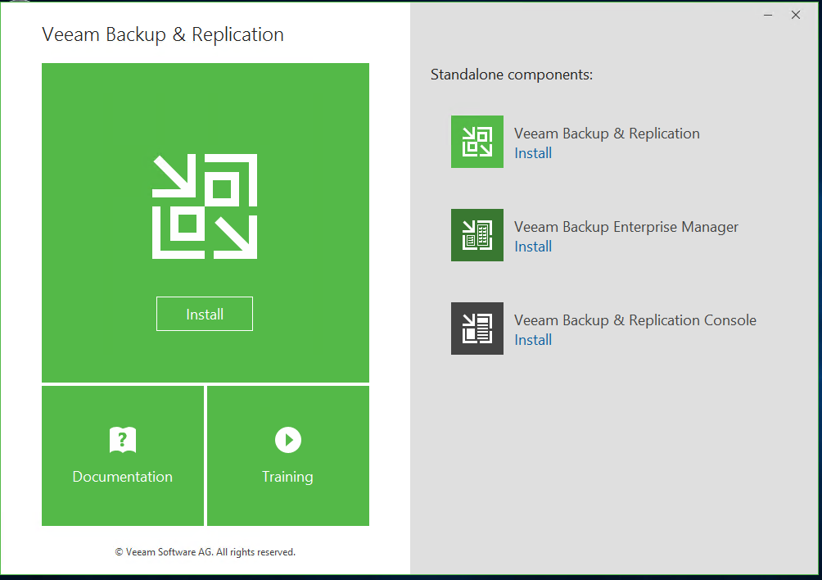
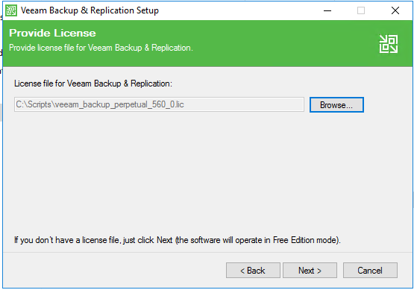

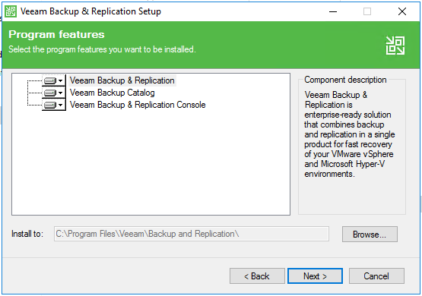

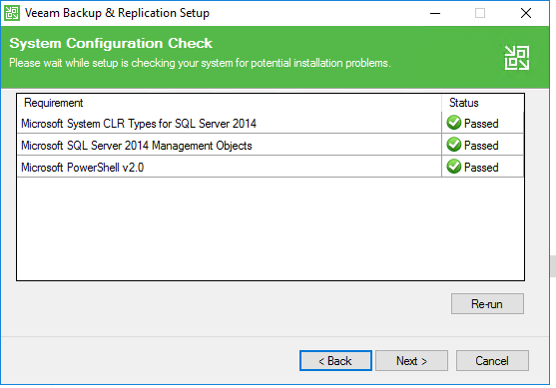

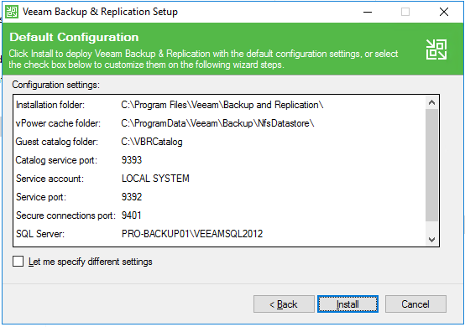

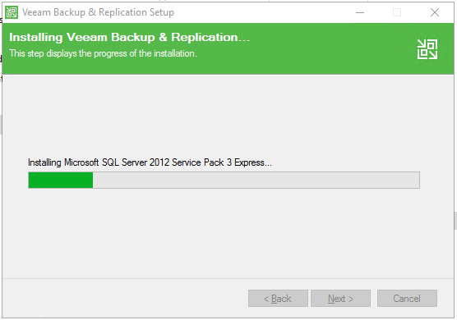

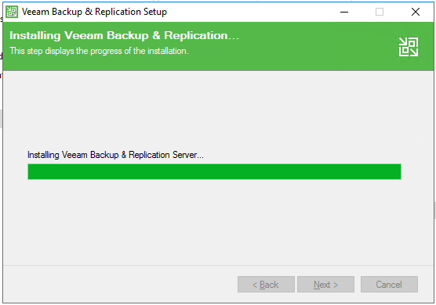

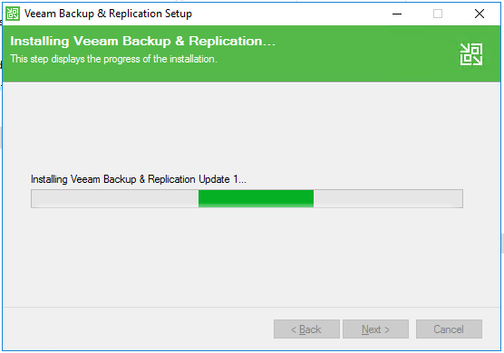

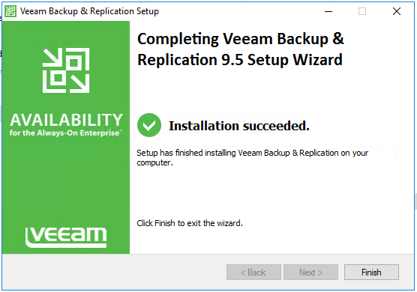
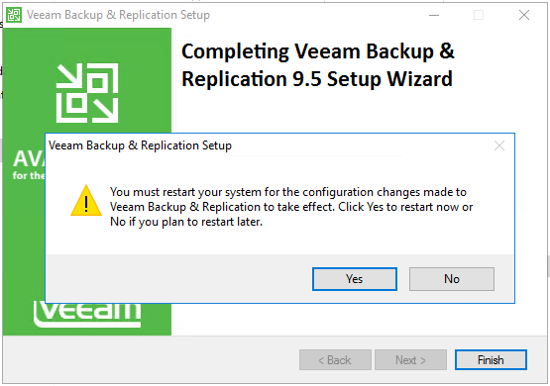

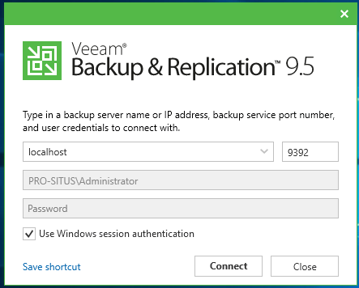

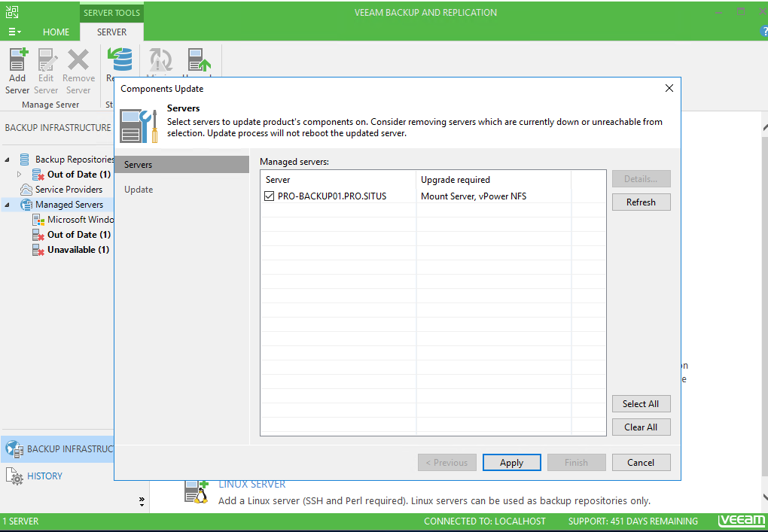

- Before you launch the script edit the following values!
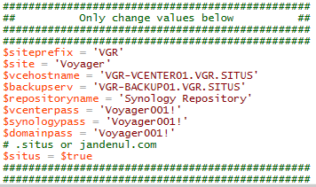

- Open the Veeam Powershell windows
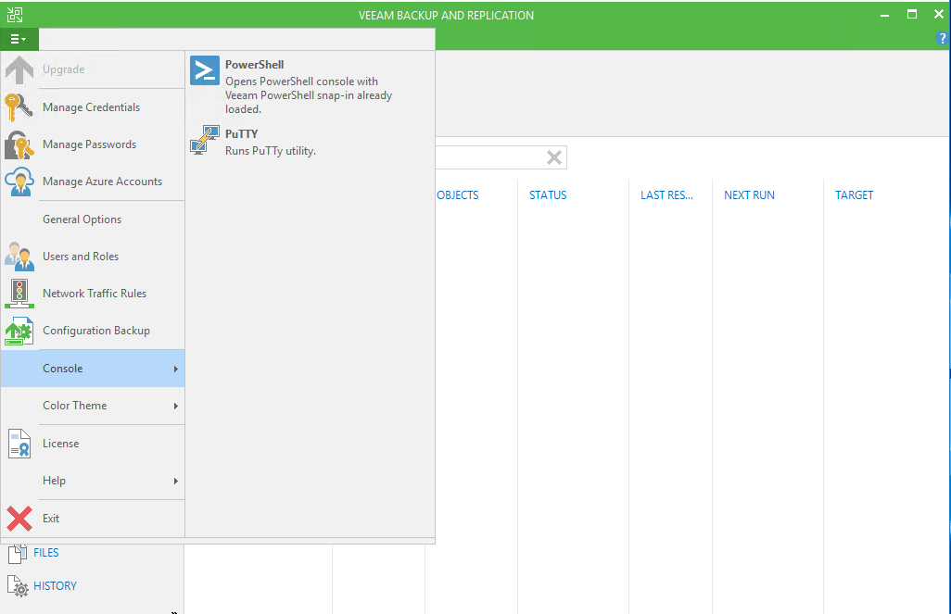

- Cd c:\scripts
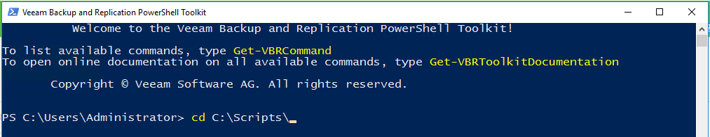
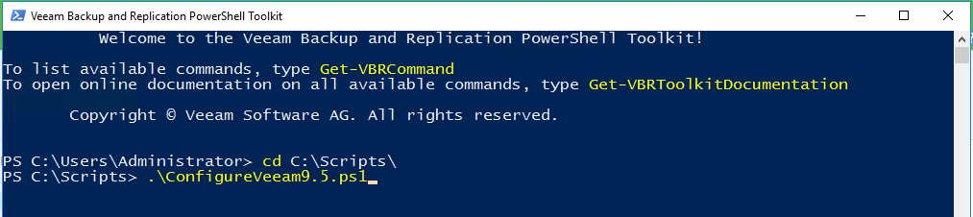

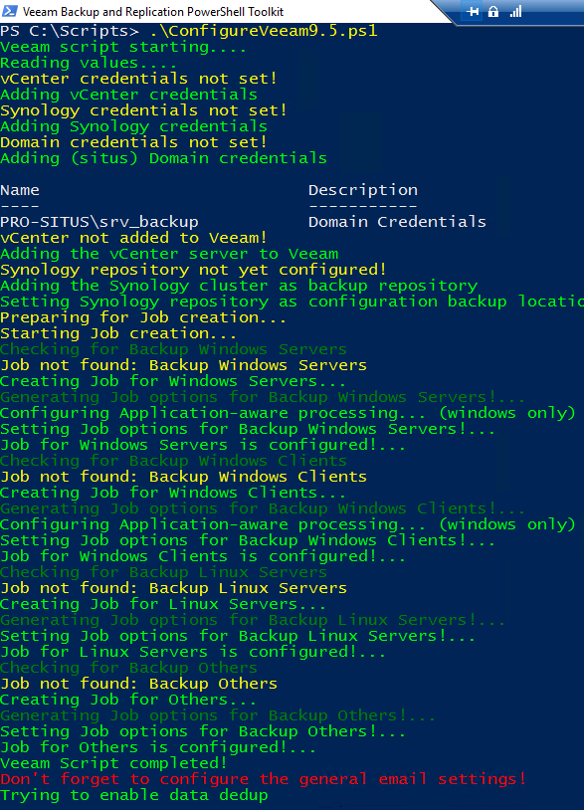

- Go to General Options
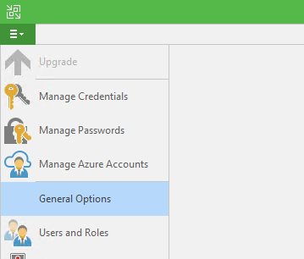
- Fill in the correct email settings
